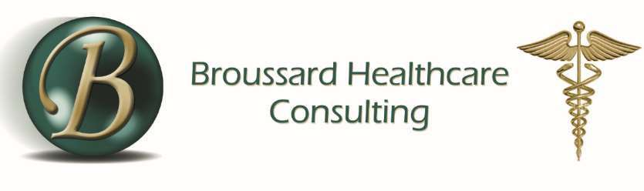
Registration Form – MDS Training
Join us January 14th-15th, 2026 for a valuable MDS Training. The fee to attend the 2026 2-day MDS Training is $350.00. The registration fee includes full access to all conference sessions, up to 11.5 CE contact hours, continental breakfast, lunch, and refreshments each day, handouts and conference materials, valuable networking opportunities, and a certificate of completion for CE credit.
Lodging and the conference will be held at Paragon Casino Resort in Marksville, LA. To reserve your room, call 800-642-7777 and mention Broussard MDS Training code BRJ13GR, to receive the group rate.
Please fill out the following:
Name: __________________________________________________________________________
Facility: _________________________________________________________________________
Address: ________________________________________________________________________
City: ___________________________State:____________________ Zip:____________________
Phone:______________________________________Fax:_________________________________
Email:___________________________________________________________________________
Payment Information:
Check/ Money Order—Amt. Encl. $
(Make checks out to Broussard Healthcare Consulting)
Credit Card: VisaM/cAmex (No Debit Cards Accepted)
Credit Card# :________-_________-_________-_________Exp.:______ ___CVAT#:__________
Name on Credit Card:______________________________________________________________
Billing address (if different from above):_______________________________________________
City: ___________________________State:____________________ Zip:____________________
Authorized Signature:______________________________________________________________
Mail this completed form to:
Attn: Ashley Granger
Broussard Healthcare Consulting
127 West Broad Street, Lake Charles, LA 70601
Email to: Ashley.Granger@bc-cpa.com
Northwestern State University’s Nursing Continuing Education is accredited as a provider of nursing continuing professional development by the American Nurses Credentialing Center’s Commission on Accreditation.
This event is Joint-Provided by NSU Nursing Continuing Education and Broussard Healthcare Consulting LLC
11.5 Contact Hours of Nursing Continuing Professional Development will be awarded to Registered Nurses upon the completion of the offering (full attendance is required)
NSU and ANCC do not approve or endorse any commercial product or company associated with this educational activity.

